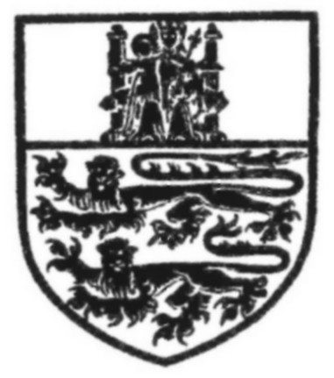

The Cathedral Church of the Blessed Virgin Mary of Lincoln

Services and Music for July 2008

13 SUNDAY Services today sung by the Cathedral Chamber Choir
0745 Litany
EIGHTH SUNDAY 0800 Holy Communion [Order Two]
AFTER TRINITY 0930 SUNG EUCHARIST [Order One] and Baptism of Jack Hughes AMNS 146, 402, 349 (t.422),
Haydn: Little Organ Mass 338
Tavener: The Lamb Prayer G
Preacher: The Precentor
1115 MATTINS Responses:
Stanford in B flat Pss. 64, 65
Joubert: O Lorde, the maker of al thing AMNS 230
Canon-in-Residence 1230 Holy Communion [Order Two]
THE CHANCELLOR 1530 LINCOLNSHIRE COUNTY COUNCIL CIVIC SERVICE Special order of service
The Revd. Canon Prof. Field: Psalm 150
M.F. West, M.A., Ph.D. Preacher: The Bishop
_______________________________________________________________________________________________________________________
14 MONDAY Services this week sung by the Anglican Chorale of Ottawa
John Keble, 0730 Mattins [St Hugh’s Shrine]
priest, poet, 1866 0800 Holy Communion [Order One: Works’ Chantry]
1230 Holy Communion [Order One: St Hugh’s Shrine]
1730 EVENSONG attended by the High Court Responses: Reading
Purcell in G minor NEH 223, 341
Purcell: Thou knowest, Lord Ps. 119 (vv.161-176)
1900 ORGAN RECITAL by Stephen Tharp, New York
_______________________________________________________________________________________________________________________
15 TUESDAY 0730 Mattins [St Hugh’s Shrine]
Swithun, 0800 Holy Communion [Order One: Morning Chapel]
bishop, c.862 1030 Holy Communion [Order Two: Fleming Chantry]
Bonaventure, friar, 1230 Holy Communion [Order One: St Hugh’s Shrine]
bishop, teacher of 1730 EVENSONG Responses: Ayleward
the faith, 1274 Byrd: Second Service NEH 221, 496 (t. 354)
Byrd: Sing joyfully Pss. 120, 121, 122
_______________________________________________________________________________________________________________________
16 WEDNESDAY 0730 Mattins [St Hugh’s Shrine] Lincoln Mystery Plays
Osmund, bishop, 1099 0800 Holy Communion [Order One: Ss Peter and Paul Chapel]
Anne Askew, 1546 1200 Litany [Longland Chantry]
1230 Holy Communion [Order One: St Hugh’s Shrine]
1730 Evening Prayer [St Hugh’s Shrine]
_______________________________________________________________________________________________________________________
17 THURSDAY 0730 Mattins [St Hugh’s Shrine] Lincoln Mystery Plays
0800 Holy Communion [Order One: Ringers’ Chapel]
1030 Holy Communion [Order Two: Airmen’s Chapel]
1230 Holy Communion [Order One: St Hugh’s Shrine]
1730 EVENSONG Responses: Shephard
Larkin: St Mary’s Service OH 6, NEH 343
Lauridsen: O Nata Lux Pss. 126, 127
_______________________________________________________________________________________________________________________
18 FRIDAY 0730 Mattins [St Hugh’s Shrine] Lincoln Mystery Plays
Elizabeth Ferard, 0800 Holy Communion [Order Two: St Blaize Chapel]
deaconess, 1883 1200 Litany [Longland Chantry]
1230 Holy Communion [Order One: St Hugh’s Shrine]
1730 EVENSONG Responses: Ayleward
Ruffo: Plainsong in B OH 7, NEH 466
Mundy: O Lord, the Maker of all thing
_______________________________________________________________________________________________________________________
19 SATURDAY 0730 Mattins [St Hugh’s Shrine] Lincoln Mystery Plays
Gregory, bishop, and 0800 Holy Communion [Order One: Sailors’ Chapel]
his sister, Macrina, 1230 Holy Communion [Order One: St Hugh’s Shrine]
deaconess, teachers of 1500 Nuptial Eucharist - Aric Prentice & Clea Tappin
the faith, c.394 and c.379 1730 EVENSONG Responses: Sumsion
Murrill in E OH 1, NEH 443
S.S. Wesley: Ascribe unto the Lord Pss. 130, 131
_______________________________________________________________________________________________________________________
Aric Prentice, Director of Music Gavin Kirk, Precentor
Charles Harrison, Assistant Director of Music

